Pharmacy E-Commerce with Prescription Validation
A Project Report Submitted in the partial fulfilment of the requirements for the award of thedegreeof

BACHELOR OF TECHNOLOGY
In
DEPARTMENT OF COMPUTER SCIENCE ENGINNERING
&
DEPARTMENT OF COMPUTER SCIENCE AND INFORMATION TECHNOLOGY
By
B. Jhahnavi :2520030452
P. Mouvya sri :2520030449
K. Yagnesh :2520030121

Under the Esteemed Guidance of


K L (Deemed to be) University
DEPARTMENT OF COMPUTER SCIENCE ENGINEERING
&
DEPARTMENT OF COMPUTER SCIENCE AND INFORMATIONTECHNOL


Declaration
The Project Report entitled “Pharmacy E-Commerce with Prescription Validation” is a record of Bonafide work of B. Jhahnavi – 2520030452, P.Mouvya Sri – 2520030449, K. Yagnesh – 2520030121, Submitted in partial fulfillment for the award of B. Tech in Computer Science and Engineering(or)Computer Science and Information Technology to the K L University. The results embodied in this report have not been copied from any other departments/University/Institute.

B. Jhahnavi - 2520030452
P. Mouvya Sri – 2520030449
K. Yagnesh - 2520030121

K L (Deemed to be) University
DEPARTMENT OF COMPUTER SCIENCE ENGINEERING
&
DEPARTMENT OF COMPUTER SCIENCE AND INFORMATIONTECHNOLOGY

CERTIFICATE
This is certify that the mini project based report entitled “Pharmacy E-Commerce with Prescription Validation” is a bonafide work done and submitted by B. JHAHNAVI -2520030121, P. MOUVYA SRI – 2520030449, K. YAGNESH - 2520030121 in partial fulfillment of the requirements for the award of the degree of BACHELOR OF TECHNOLOGY in Department of Computer Science Engineering, K L (Deemed to be University) ,during the academic year 2024-2025.

Signature of the Guide

Signature of the Course Coordinator Signature of the HOD

ACKNOWLEDGEMENT

The success in this project would not have been possible but for the timely help and guidance rendered by many people. Our wish to express my sincere thanks to all those who has assisted us in one way or the other for the completion of my project.

Our greatest appreciation to my Course Coordinator , and my guide Department of Computer Science which cannot be expressed in words for his/her tremendous support, encouragement and guidance for this project.

We express our gratitude to Head of the Department for Computer Science Engineering/ Department for Computer Science and Information Technology for providing us with adequate facilities, ways and means by which we are able to complete his project-based Lab.

We thank all the members of teaching and non-teaching staff members, and also who have assisted me directly or indirectly for successful completion of this project. Finally, I sincerely thank my parents, friends and classmates for their kind help and cooperation during my work

B. JHAHNAVI – 2520030452
P. MOUVYA SRI – 2520030449
K. YAGNESH - 2520030121
.

Abstract
The Pharmacy E-Commerce with Prescription Validation system, developed under the brand name PharmaCare, is a web-based healthcare platform designed to provide a centralized and secure environment for purchasing medicines, submitting medical prescriptions, managing orders, and accessing diagnostic laboratory services. The primary objective of the system is to address the limitations of conventional online medicine-shopping platforms by introducing prescription validation as a core part of the purchasing workflow. Instead of treating medicine purchasing and prescription verification as completely separate activities, the proposed system connects these processes through a unified digital platform, allowing customers to upload prescriptions and enabling authorized pharmacists to review and validate them before prescription-based medicines are processed.
The system provides different interfaces and responsibilities for customers, pharmacists, administrators, and delivery-related operations. Customers can register and securely log in, browse medicines, view medicine details, upload prescriptions, manage their shopping cart, place orders, track orders, manage previously uploaded prescriptions, book laboratory tests, and access refill-related services. Prescription records are maintained with their verification status so that customers can monitor whether a prescription is pending, approved, or rejected. This creates a transparent workflow between the customer and pharmacy staff while reducing the dependency on manual communication for every prescription-related order.

Index
S.  No | Chapters | Topics | Page no
Acknowledgement
Abstract
1 | Introduction | 1.1 Background of the project  1.2 Problem statement  1.3 Scope of the project  1.4 Objective(s)  1.5 Importance of the application  1.6 Target users/audience | 5-15
2 | System Requirements | 2.1 Hardware requirements  2.2 Software requirements  2.3 Development tools and frameworks | 16-21
3 | Technology Stack | 3.1 Front-end (e.g., React.js, Angular, HTML/CSS)  3.2 Back-end (e.g., Node.js, Express.js)  3.3 Database (e.g., MongoDB)  3.4 Version Control (e.g., Git, GitHub)  3.5 APIs or External services (e.g., Firebase, Stripe) | 22-32
4 | System Architecture | 4.1 High-level architecture diagram  4.2 Description of each layer (frontend, backend, database)  4.3 Deployment architecture (e.g., cloud, local, CI/CDpipelines) | 33-36
5 | Design | 5.2 ER Diagram / Database schema | 37
6 | Implementation | 6.1 Module-wise implementation  6.2 Front-end logic (UI rendering, state management) 6.3 API integration  6.4 Authentication & Authorization | 38-47
7 | Features | 7.1 List of main features  7.2 How each feature works (user perspective + technical description) | 48-55
8 | Testing | 8.1 Postman testing (frontend/backend)  8.2 Integration testing  8.3 Tools used for testing  8.4 Test cases and results | 56-64
9 | Deployment | 9.1 Steps to deploy  9.2 Environment configuration  9.3 Hosting of frontend and backend | 65-73
10 | Challenges &Limitations | 10.1 Issues faced during development  10.2 Solutions applied  10.3 Current limitations or known bugs | 73-76
11 | Future Enhancements | 11.1 Planned features  11.2 Possible integrations or optimizations | 77-85
12 | Conclusion | 12.1 Summary of the project 12.2 What was achieved  12.3 Skills learned during development | 89-97
13 | References | - Books, tutorials, APIs, documentation sites used | 98-99
14 | Appendices | - Screenshots of the app  - Sample code snippets  - Installation/setup instructions  - User manual or guide  -Geo Tag photos with guide  -Review forms with guide signatures | 100-105

CHAPTER -1 INTRODUCTION
  - Background of the Project
The rapid growth of internet-based services has significantly changed the way healthcare products and services are accessed by customers. Online pharmacy platforms have become an important part of this transformation by allowing users to search for medicines, compare available products, place orders, and receive medicines at their preferred location. These platforms reduce the need for customers to visit a physical pharmacy for every purchase and provide convenient access to medicine-related information. Along with these advantages, online pharmacy systems also introduce additional requirements because certain medicines can only be supplied after verifying a valid medical prescription.
In a conventional pharmacy environment, prescription verification is generally performed directly by a pharmacist. The customer presents the prescription, and the pharmacist examines the prescribed medicines, dosage information, patient details, and other relevant information before allowing the purchase. Although this process provides direct professional supervision, it can become difficult to manage efficiently when the number of customers and prescriptions increases. In online pharmacy systems, the problem becomes more complex because the prescription has to be submitted digitally and reviewed before the corresponding medicines can be processed.
The Pharma Care Pharmacy E-Commerce with Prescription Validation project is developed in response to these requirements. The system combines the features of an online pharmacy with a dedicated prescription validation workflow. Customers can create accounts, browse medicines, upload prescriptions, manage their cart, place orders, and monitor the status of their prescriptions and orders. Authorized pharmacists can access submitted prescriptions, review the provided information, record verification details, and approve or reject prescriptions before prescription-based medicines are processed.
The project also provides a centralized database for maintaining information related to users, medicines, prescriptions, orders, laboratory services, reminders, notifications, and other application activities. This centralized approach helps establish a consistent connection between customers, pharmacy personnel, and administrative operations. The use of authentication and role-based authorization ensures that different users can access only the functionality relevant to their responsibilities.
The background of the project is also connected with the increasing importance of digital healthcare services. Customers increasingly expect healthcare platforms to provide multiple services through a single interface rather than requiring separate applications for medicine purchases, prescription submission, laboratory bookings, and order management. Pharma Care therefore incorporates additional healthcare-oriented modules such as laboratory test booking, order tracking, refill reminders, and role-specific dashboards along with its core pharmacy functionality.
  - Problem Statement

The increasing use of online healthcare and pharmacy services has created a need for reliable systems that can provide medicines conveniently while maintaining proper control over prescription-required medicines. Traditional pharmacy purchasing requires customers to visit a physical pharmacy and present their prescriptions directly to a pharmacist. Although this allows immediate verification, the process can be inconvenient for customers and provides limited digital tracking of prescriptions, orders, and verification activities.
Existing online pharmacy platforms mainly focus on medicine searching, product selection, cart management, payment, and delivery. However, prescription verification can remain a separate or partially manual process. This creates difficulties in connecting a customer's prescription with the medicines being ordered and in maintaining a clear record of whether a prescription has been submitted, reviewed, approved, or rejected. Customers may also have limited visibility into the status of their prescription, while pharmacists may need to manually manage prescription documents and customer order information.
Another significant problem is the controlled purchase of medicines that require a valid prescription. Without an organized prescription-validation workflow, it becomes difficult to ensure that prescription-based medicines are processed only after appropriate pharmacist review. The absence of a centralized system can also result in difficulties in maintaining prescription history, verification records, order information, and communication between customers and pharmacy personnel.
There is also a need for an integrated platform that provides more than basic medicine purchasing. Customers may require additional services such as laboratory test booking, order tracking, refill reminders, medicine history, and notifications. Managing these services through separate processes can reduce convenience and make healthcare-related information more difficult to organize.
Therefore, the problem addressed by this project is the lack of a centralized pharmacy e-commerce system that combines online medicine purchasing with a structured prescription submission and pharmacist validation process while also supporting order management and additional healthcare services.

  - Scope of the Project
The scope of the “Pharma Care Pharmacy E-Commerce with Prescription Validation” project covers the development of an integrated web-based platform for online medicine purchasing and prescription-based healthcare services. The system is designed to connect customers, pharmacists, administrators, and delivery-related operations through a common digital platform. The project focuses particularly on providing a structured process for prescription submission and validation along with the normal activities involved in an online pharmacy.
The customer side of the system covers user registration, secure login, medicine browsing, medicine search, medicine details, shopping cart management, checkout, prescription upload, order placement, order history, and order tracking. Customers can view information about medicines such as their name, generic name, category, dosage, price, availability, and prescription requirement. The system also provides customers with access to their prescription history and relevant order information through their personal dashboard.
A major part of the project scope is the prescription validation workflow. Customers can upload prescription documents through the platform, and the uploaded prescriptions are stored and made available to authorized pharmacy personnel for review. Pharmacists can examine prescription information, review the submitted document, record relevant observations, and update the prescription status. The system supports statuses such as pending, processing, approved, and rejected, allowing customers to understand the current stage of their prescription. Prescription-related audit information can also be maintained to improve traceability of the validation process.
The scope also includes medicine and inventory management. Administrators and authorized pharmacy personnel can manage medicine information, including medicine names, generic names, categories, dosage forms, prices, stock quantities, manufacturers, prescription requirements, and other product information. The system can maintain medicine availability and support operational activities related to stock management. This provides a centralized approach for maintaining the medicine catalogue instead of relying on separate manual records.
The project scope is further extended to laboratory diagnostic services. Customers can browse available laboratory tests, view test information and pricing, select diagnostic centers, and create laboratory bookings. The system maintains laboratory test, laboratory center, and booking information. The laboratory booking workflow supports different stages of the booking lifecycle, allowing the system to represent the progress of a diagnostic service from confirmation through sample collection, testing, and report availability.
The system also includes customer-supporting healthcare features such as refill reminders, notifications, medicine history, and customer dashboards. These features are intended to improve the continuity of healthcare-related activities after the initial medicine purchase. Customers can access relevant information from a centralized dashboard rather than managing each activity separately.

  - Objectives of the Project

The main objective of the Pharma Care Pharmacy E-Commerce with Prescription Validation project is to develop a centralized web-based pharmacy platform that allows customers to purchase medicines online while providing a structured prescription validation process. The system is designed to connect customers, pharmacists, and administrators through a single platform and provide a convenient and organized method for managing medicines, prescriptions, orders, and related healthcare services.
The project aims to provide customers with an easy-to-use platform for searching, browsing, and purchasing medicines online. Customers can view important medicine information such as the medicine name, generic name, category, dosage, price, availability, manufacturer, and prescription requirement. The system is intended to make medicine purchasing more convenient by allowing customers to manage their selections through a shopping cart and complete the order process through the application.
A major objective of the project is to implement a digital prescription submission and validation system. Customers can upload their prescriptions through the platform, while authorized pharmacists can access and review the submitted prescriptions. Pharmacists can examine the prescription information and update its status according to the review process. This provides a structured workflow for handling prescription-required medicines instead of depending completely on manual communication between customers and pharmacy personnel.
The project also aims to connect prescription validation with the medicine ordering process. Prescription-required medicines should be handled through an appropriate verification workflow before they are processed for purchase. Maintaining prescription status and related information helps the system organize the relationship between prescriptions and medicine orders and provides customers with better visibility into the progress of their prescription requests.
The project aims to provide medicine and inventory management functionality for authorized personnel. Medicine records can contain information such as medicine name, generic name, category, dosage form, price, stock quantity, manufacturer, and prescription requirements. Centralizing this information helps administrators and pharmacy personnel maintain the medicine catalogue and monitor the availability of medicines within the system.
The system also aims to provide order management and order tracking facilities. Customers can view their current and previous orders and access relevant order information through their account. The system maintains order details and status information so that customers can follow the progress of their orders after placing them.

  - Importance of the Application
The PharmaCare Pharmacy E-Commerce with Prescription Validation application is important because it provides a centralized digital platform for purchasing medicines and managing prescription-based healthcare services. It combines online pharmacy facilities with a structured prescription validation workflow, making the process more organized for customers and pharmacy personnel. Instead of handling medicine purchasing and prescription verification through separate processes, the application brings these activities together within a single system.
The application improves convenience and accessibility for customers by allowing them to browse medicines, view medicine information, upload prescriptions, place orders, and monitor order status through an online platform. Customers do not need to depend entirely on physical visits to a pharmacy for every medicine-related activity. The availability of prescription and order information within the customer account also provides a more organized way of managing their pharmacy requirements.
The application is particularly important for prescription-based medicine management. Prescription-required medicines need appropriate verification before they are processed. Pharma Care provides a dedicated workflow through which customers can submit prescriptions and authorized pharmacists can review them. The prescription status can be maintained as part of the system, providing a clear record of whether a prescription is awaiting review, being processed, approved, or rejected.
The system is also important from the perspective of pharmacists and pharmacy administrators. Instead of managing prescription documents, medicine information, customer requests, and orders through separate manual processes, authorized personnel can access these activities through dedicated dashboards. This helps organize pharmacy operations and provides a centralized view of important application activities.
From a security perspective, the application provides authentication and role-based access control to separate the responsibilities of customers, pharmacists, and administrators. This is particularly relevant because the system handles prescription documents, user information, medicine records, and order-related data. Restricting access according to user roles helps maintain controlled access to different parts of the application.
Overall, the importance of PharmaCare lies in its ability to provide a centralized, organized, and convenient pharmacy and healthcare platform. By combining online medicine purchasing, prescription validation, pharmacist review, order management, laboratory booking, reminders, notifications, and role-based dashboards, the application provides a structured foundation for managing digital pharmacy services and can be further extended with advanced healthcare and intelligent pharmacy features.

  - Target Users / Audience
The PharmaCare Pharmacy E-Commerce with Prescription Validation application is designed for different categories of users who are involved in online pharmacy and healthcare-related activities. The system provides separate functionalities based on the responsibilities and requirements of each user category.
Customers are the primary users of the application. They can register and securely log in to the platform, browse and search for medicines, view medicine details, upload prescriptions, add medicines to the shopping cart, place orders, and track their orders. They can also view their prescription history, receive relevant notifications and refill reminders, and book laboratory tests through the application. The platform provides customers with a centralized interface for managing their pharmacy and healthcare-related activities.
Pharmacists are authorized users responsible for reviewing and validating customer prescriptions. They can access submitted prescription documents, examine the available prescription information, record relevant review details, and update the prescription status. Pharmacists can also participate in medicine and order-related operations according to their assigned permissions. Their role is important in maintaining a structured verification process for prescription-required medicines.
Administrators are responsible for managing and monitoring the overall operation of the PharmaCare platform. They can manage users, medicines, inventory-related information, prescriptions, orders, laboratory tests, laboratory centers, and other system-level information. The administrator dashboard provides centralized access to important operational activities and helps maintain the application's data and configuration.
Laboratory-related operations involve personnel or authorized users responsible for managing diagnostic tests, laboratory centers, and laboratory bookings. They can maintain information about available tests and centers and manage relevant booking stages. This supports the integration of diagnostic services within the Pharma Care platform.

CHAPTER -2 SYSTEM REQUIREMENTS
2.1 Hardware Requirements
The Pharma Care – Pharmacy E-Commerce with Prescription Validation system is a web-based application that requires a standard computer system capable of supporting frontend development, backend development, database operations, testing, and web browsing. Since the project is developed using technologies such as React.js, Vite, Node.js, Express.js, MongoDB, and Mongoose, the hardware requirements are moderate and can be supported by most modern computers. The system should have a minimum of 8 GB RAM, while 16 GB RAM or higher is recommended for smooth execution of the frontend, backend server, MongoDB services, Visual Studio Code, browser, and other development tools simultaneously.
The processor plays an important role in compiling the application, running the Node.js backend, managing the MongoDB connection, and executing multiple development tools. A minimum of an Intel Core i3 or AMD Ryzen 3 equivalent processor is sufficient for basic development and testing. However, an Intel Core i5, AMD Ryzen 5, or higher processor is recommended for better performance, especially when running the frontend and backend servers together, testing different user roles, managing prescription uploads, and working with multiple browser tabs and development applications.
For storage, the system should have at least 256 GB of available storage, preferably using an SSD. An SSD provides faster application loading, project build operations, database access, and file management compared with a traditional hard disk. A 512 GB SSD or higher is recommended because the project contains source-code files, Node.js dependencies, MongoDB-related data, uploaded prescription documents, medicine images, testing files, documentation, and other academic project resources.
The display should provide sufficient resolution for designing and testing the PharmaCare user interface. A minimum resolution of 1366 × 768 pixels can be used for development, while a 1920 × 1080 Full HD display or higher is recommended. A higher-resolution display makes it easier to work with the VS Code editor, browser developer tools, database interfaces, Postman, dashboards, and multiple project files without excessive scrolling.
A dedicated graphics card is not mandatory for the PharmaCare project because the application primarily involves web development, database operations, and server-side processing rather than graphics-intensive computation. Integrated graphics are sufficient for normal development and testing. A dedicated GPU may be useful for general development workloads or future extensions involving more computationally intensive AI or machine-learning functionality, but it is not a compulsory requirement for the current system.
A stable internet connection is required for installing project dependencies, accessing MongoDB Atlas when used, downloading development packages, testing APIs, accessing external services, and performing web-based testing. Wi-Fi or Ethernet connectivity can be used. A stable high-speed broadband connection is recommended to avoid interruptions while installing packages, connecting to cloud services, or testing the application.
2.2 Software Requirements
The Pharma Care – Pharmacy E-Commerce with Prescription Validation system requires a suitable software environment for developing, executing, testing, and maintaining the web-based pharmacy application. The software requirements include the operating system, frontend development technologies, backend technologies, database management system, development environment, API testing tools, web browser, and supporting libraries. These software components work together to provide a complete environment for implementing medicine management, customer registration and login, prescription upload and validation, pharmacist approval, order management, payment testing, laboratory services, and role-based dashboards.
The operating system provides the basic environment required to install and execute all the development tools and application components. The system can be developed and tested on Windows 10 or Windows 11, which provides compatibility with Visual Studio Code, Node.js, MongoDB tools, Git, Postman, and modern web browsers. A 64-bit operating system is recommended for better compatibility with current development software and database tools.
The frontend of PharmaCare is developed using React.js with Vite. React.js is used to create the interactive and component-based user interface of the application, while Vite provides a fast development and build environment. The frontend is responsible for customer registration and login, medicine browsing and searching, medicine details, prescription upload, shopping cart, checkout, order tracking, laboratory test booking, customer dashboard, and other user-facing features. HTML, CSS, and JavaScript are also used as fundamental web technologies for structuring, styling, and implementing the application's interface and functionality.
The backend of the system is developed using Node.js and Express.js. Node.js provides the runtime environment for executing server-side JavaScript, while Express.js is used to create the RESTful APIs required for communication between the frontend and backend. The backend manages authentication, users, medicines, prescriptions, orders, laboratory services, reminders, notifications, delivery operations, and administrative functions. It also handles requests from different user roles and communicates with the database to store and retrieve application data.
The database requirement for PharmaCare is MongoDB with Mongoose. MongoDB is a NoSQL database used to store application information such as customer accounts, pharmacist and administrator accounts, medicine details, prescription records, orders, laboratory tests, laboratory bookings, reminders, reviews, and other system-related data. Mongoose is used as the object data modeling library for Node.js and provides schemas, validation, and structured interaction between the Express backend and MongoDB database.

For authentication and security, the application uses JSON Web Token (JWT) based authentication. JWT allows authenticated users to access protected resources while maintaining role-based access within the application. Different roles such as customer, pharmacist, administrator, and delivery personnel can be provided with access to the functions relevant to their responsibilities. Authentication and authorization mechanisms help protect sensitive operations such as prescription review, medicine management, order management, and administrative activities.
2.3 Development Tools and Frameworks
The development of the PharmaCare – Pharmacy E-Commerce with Prescription Validation system requires a combination of development tools and software frameworks to build, test, and manage the application. These tools support the development of the frontend, backend, database, authentication, prescription upload, API communication, and overall application testing. The main development environment consists of Visual Studio Code, React.js, Vite, Node.js, Express.js, MongoDB, Mongoose, JWT, Multer, npm, and Postman.

CHAPTER -2 TECHNOLOGY STACK
3.1 Front-end Technologies
The frontend of PharmaCare is developed using React.js, Vite, HTML, CSS, and JavaScript. These technologies provide an interactive and user-friendly interface for customers, pharmacists, administrators, and delivery personnel.
React.js
React.js is used to create reusable UI components and manage the different sections of the application. The frontend is divided into components to improve code organization, reusability, and maintainability.
The main frontend functionalities include:
- User registration and login.
- Medicine browsing and searching.
- Medicine details and product display.
- Shopping cart management.
- Prescription upload.
- Customer dashboard.
- Pharmacist dashboard.
- Administrator dashboard.
- Order tracking.
- Laboratory test booking.
HTML
HTML is used to define the structure of the application's web pages, including forms, navigation sections, buttons, and content areas.
CSS
CSS is used to design and style the user interface. It provides layouts, colors, spacing, responsive elements, and visual consistency across the application.
JavaScript
JavaScript is used to implement interactive functionality and handle user actions. It also supports communication between the frontend and backend APIs.
Vite
Vite provides the development server and build environment for the React application. It helps developers run and test the frontend efficiently.
3.2 Back-end Technologies
The backend of PharmaCare is developed using Node.js and Express.js. It acts as the communication layer between the frontend and database.
Node.js
Node.js executes the backend JavaScript code and handles server-side operations. It processes requests from different users and communicates with the database.
Express.js
Express.js is used to develop RESTful APIs that connect frontend components with backend operations.
The backend handles:
- User authentication.
- Medicine management.
- Prescription management.
- Order processing.
- Inventory management.
- Laboratory test management.
- Laboratory booking.
- Delivery operations.
- Notifications and reminders.
The backend is organized using routes, controllers, models, middleware, and configuration files. This modular structure makes the application easier to maintain and extend.
3.3 Database – MongoDB
MongoDB is used as the primary database for storing PharmaCare application information.
It is a NoSQL database that stores information in flexible document-based structures.
Mongoose is used to define schemas and perform database operations.
Main Database Collections
Collection / Model | Purpose
User | Stores user account information
Medicine | Stores medicine details
Prescription | Stores prescription information
PrescriptionAudit | Maintains prescription review history
Order | Stores customer order information
OrderStatusHistory | Maintains order status history
InventoryBatch | Stores inventory batch details
LabTest | Stores laboratory test details
LabCenter | Stores laboratory center information
LabBooking | Stores laboratory booking details
Notification | Stores notification information
Reminder | Stores refill reminders
Review | Stores customer reviews
The database provides centralized storage and allows different application modules to access relevant information.
3.4 Version Control – Git and GitHub
Git is a distributed version control system used to track changes in source code during development.
GitHub is an online platform that supports hosting and managing Git repositories.
Version control helps developers maintain project history, collaborate with team members, and manage changes to application files.
The PharmaCare source code can be maintained in a GitHub repository to provide centralized access to project files and support future development.
3.5 APIs and External Services
PharmaCare uses RESTful APIs to establish communication between the frontend and backend.
The frontend sends HTTP requests to the backend, and the backend processes these requests and communicates with MongoDB.
Main API Categories
API Category | Purpose
Authentication API | Registration and login
Medicine API | Medicine information and management
Prescription API | Prescription submission and review
Order API | Order creation and tracking
Inventory API | Stock management
Laboratory API | Test and center management
Booking API | Laboratory booking
Notification API | Notification management
Reminder API | Refill reminders
Delivery API | Delivery-related operations
JWT is used for authentication, while Multer handles prescription document uploads.
The current project includes these backend modules. External payment gateway integration should be described as a future enhancement unless it has been implemented and tested.
CHAPTER – 4 SYSTEM ARCHITECTURE
4.1 High-Level Architecture Diagram
The PharmaCare application follows a three-layer architecture consisting of the presentation layer, application layer, and database layer.
The frontend provides interfaces for different users. The backend processes requests, performs business logic, manages authentication, and communicates with the database. MongoDB stores the information required by the application.
Architecture Diagram

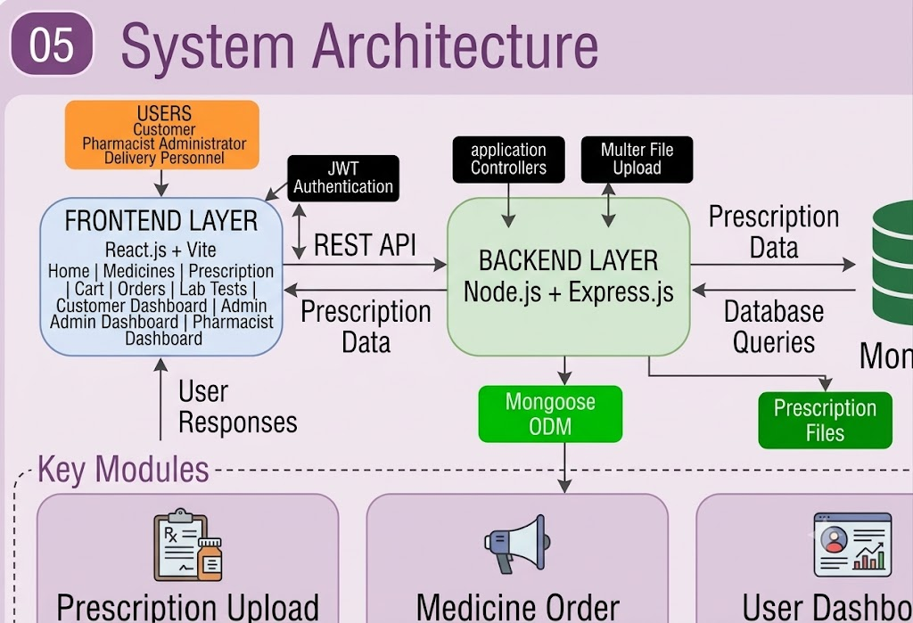

4.2 Description of Each Layer
1. Presentation Layer (Frontend)
The presentation layer is developed using React.js and Vite. It provides the user interface through which customers, pharmacists, administrators, and delivery personnel interact with the application.
The frontend displays medicine information, registration forms, login pages, prescription upload forms, dashboards, order details, and laboratory booking interfaces.
React components are used to organize the interface into reusable sections.
2. Application Layer (Backend)
The application layer is developed using Node.js and Express.js. It receives requests from the frontend, processes them, and performs the required operations.
The backend includes routes, controllers, middleware, and database models.
The major responsibilities of this layer include:
- Processing user registration and login.
- Managing medicines and inventory.
- Handling prescription submissions.
- Supporting pharmacist prescription reviews.
- Managing customer orders.
- Processing laboratory bookings.
- Handling notifications and reminders.
- Managing delivery-related operations.
JWT middleware is used to protect authenticated operations. Multer is used to handle prescription file uploads.
3. Database Layer
The database layer uses MongoDB with Mongoose.
MongoDB stores application data such as users, medicines, prescriptions, orders, laboratory tests, bookings, and notifications.
Mongoose provides schemas and methods for interacting with MongoDB from the backend.
The database layer ensures that application information is maintained centrally and can be retrieved whenever required.
4.3 Deployment Architecture
The PharmaCare application is designed using separate frontend and backend components.
During development, the frontend and backend can run independently on the local system.
The frontend development server is started using Vite, while the backend server is executed using Node.js.
MongoDB provides database storage and can be configured for local development or cloud-based database access.
Local Deployment
The local development environment consists of:
- React.js frontend running through Vite.
- Node.js and Express.js backend.
- MongoDB database.
- Browser for accessing the frontend.
- Environment configuration for database connection and authentication.
Cloud Deployment
For future production deployment, the frontend can be hosted using a frontend hosting service, the backend can be deployed using a Node.js-compatible hosting platform, and MongoDB can be hosted through MongoDB Atlas.
A CI/CD pipeline can also be introduced to automate building, testing, and deployment whenever changes are pushed to the repository.
The actual hosting configuration should be documented after deployment is completed.
CHAPTER – 5 DESIGN
5.2 ER Diagram / Database Schema
The database design of PharmaCare is developed to maintain information related to users, medicines, prescriptions, orders, laboratory services, inventory, and notifications.
The application uses MongoDB, which stores data in collections rather than traditional relational tables. The following ER-style diagram represents the logical relationships between the main entities.
Description of Main Entities
1. User: Stores customer and authorized user account information, including personal details, email, password, and role.
2. Medicine: Stores medicine information such as name, category, price, availability, and prescription requirements.
3. Prescription: Maintains uploaded prescription details and their verification status.
4. PrescriptionAudit: Maintains records of prescription review activities.
5. Order: Stores information about customer orders, selected medicines, quantities, and order status.
6. InventoryBatch: Maintains medicine stock and batch-related information.
7. LabTest: Stores information about diagnostic tests and their prices.
8. LabCenter: Maintains laboratory center details.
9. LabBooking: Stores customer laboratory booking information.
10. Notification: Maintains notifications associated with application users.
11. Reminder: Stores refill reminder information.
12. Review: Maintains customer feedback and ratings.
13. OrderStatusHistory: Maintains the history of changes in order status.
Note: This is a logical ER-style representation. MongoDB references, embedded documents, and actual schema fields may differ from a traditional relational database.

CHAPTER – 6 IMPLEMENTATION
6.1 Module-Wise Implementation
The PharmaCare application is divided into different modules to organize its functionality and simplify development.
1. User Authentication Module
This module manages user registration and login. It verifies user credentials and provides access to the application according to authentication and role information.
2. Medicine Management Module
This module manages medicine information, including medicine names, categories, prices, descriptions, and availability.
Customers can browse medicine details, while authorized personnel can manage medicine records.
3. Prescription Management Module
This module allows customers to upload prescription documents.
The uploaded prescription is stored and made available for authorized pharmacist review. The pharmacist can update the prescription status according to the verification process.
4. Order Management Module
This module manages customer orders and order-related information.
It supports order creation, order details, and order status management.
5. Inventory Management Module
This module maintains stock information and inventory batch records. It helps authorized personnel manage medicine availability.
6. Laboratory Test Module
This module maintains diagnostic test information and laboratory center details.
Customers can access available tests and related information.
7. Laboratory Booking Module
This module allows customers to create laboratory bookings and maintain booking information.
8. Delivery Management Module
This module supports delivery-related operations and provides a dedicated interface for delivery personnel.
9. Notification Module
This module manages notifications related to application activities and user interactions.
10. Reminder Module
This module supports medicine refill reminders and helps customers maintain awareness of their medicine requirements.
11. Review Module
This module allows customer feedback and ratings to be maintained within the application.
12. Analytics Module
This module provides analytical information related to application activities through the backend analytics functionality.
6.2 Front-end Logic (UI Rendering and State Management)
The frontend of PharmaCare is developed using React.js.
React uses a component-based approach in which the user interface is divided into smaller reusable components.
Each component is responsible for displaying a particular section of the application.
UI Rendering
The application renders different interfaces according to the selected page and user role.
For example:
- Customers access medicine browsing and order-related pages.
- Pharmacists access prescription-related functionality.
- Administrators access management dashboards.
- Delivery personnel access delivery-related interfaces.
React components are used to maintain a structured user interface and reduce code duplication.
State Management
The frontend uses JavaScript and React functionality to manage user interactions and display updated information.
For example, when a customer selects a medicine, the selected medicine information can be reflected in the shopping cart interface.
When a user submits a form, the frontend handles the input and communicates with the backend API.
User Interaction Flow
- The user opens the PharmaCare website.
- The frontend displays the required page.
- The user performs an action such as login, medicine search, or prescription upload.
- The frontend collects the required information.
- The frontend sends a request to the backend.
- The backend processes the request and returns a response.
- The frontend updates the displayed information.

6.3 API Integration

API integration connects the React frontend with the Node.js and Express.js backend.

The backend provides RESTful endpoints for different application modules.

The frontend sends HTTP requests to these endpoints to perform application operations.

API Request Methods
HTTP Method | Purpose | Example
GET | Retrieve information | View medicines
POST | Create information | Register user
PUT | Update information | Update order
DELETE | Remove information | Delete a record

API Integration Process
- The user performs an action on the frontend.
- The frontend sends an HTTP request to the backend.
- Express.js receives the request through the corresponding route.
- The controller processes the request.
- The controller communicates with MongoDB through Mongoose when required.
- The backend returns a response.
- The frontend displays the result.
6.4 Authentication and Authorization
Authentication and authorization are important for protecting user accounts and controlling access to application functionality.

Authentication
Authentication verifies the identity of a user.
In PharmaCare, users provide their login credentials. The backend verifies the credentials and uses JWT-based authentication for authenticated access.
Authorization
Authorization determines which operations an authenticated user can perform.
The application supports different user roles, including:
- Customer
- Pharmacist
- Administrator
- Delivery Personnel
Each role is associated with specific application responsibilities.
CHAPTER 7 – FEATURES
7.1 List of Main Features
The PharmaCare application provides multiple features to support online medicine purchasing and prescription-based healthcare services.
The main features include:
- User registration and login.
- Role-based dashboards.
- Medicine browsing and searching.
- Medicine details and availability.
- Shopping cart management.
- Prescription upload.
- Prescription validation by pharmacists.
- Order management.
- Order tracking.
- Medicine inventory management.
- Laboratory test browsing.
- Laboratory center management.
- Laboratory test booking.
- Delivery management.
- Refill reminders.
- Notifications.
- Customer reviews.
- Analytics.
7.2 How Each Feature Works (User Perspective and Technical Description)
1. User Registration and Login
User Perspective:
Users can register by providing the required account information and log in using their credentials.
Technical Description:
The frontend collects user details and sends them to the backend authentication API. The backend validates the information and interacts with MongoDB to manage user records. JWT-based authentication is used for authenticated access.
2. Role-Based Dashboards
User Perspective:
Different users access dashboards according to their responsibilities.
Technical Description:
The frontend provides separate interfaces for different user roles. Backend authentication middleware supports protected access to relevant operations.
3. Medicine Browsing
User Perspective:
Customers can browse available medicines and view their details.
Technical Description:
The frontend retrieves medicine information through the medicine API. The backend fetches the required records from MongoDB and returns them to the frontend.
4. Medicine Search
User Perspective:
Customers can search for medicines using available search functionality.
Technical Description:
Search requests are handled by the medicine-related backend functionality, which retrieves matching medicine information.
5. Medicine Details
User Perspective:
Customers can view medicine names, descriptions, prices, and prescription requirements.
Technical Description:
The frontend displays medicine records received from the backend API.
6. Shopping Cart
User Perspective:
Customers can select medicines and manage their selected items before proceeding with an order.
Technical Description:
The frontend maintains the selected medicine information and quantity through the cart interface.
7. Prescription Upload
User Perspective:
Customers can upload prescription documents through the application.
Technical Description:
Multer middleware handles prescription file uploads. The backend processes the uploaded file and maintains associated prescription information in MongoDB.
8. Prescription Validation
User Perspective:
Customers can submit prescriptions and monitor their verification status.
Technical Description:
The prescription controller manages prescription-related operations. Authorized pharmacists can review submitted prescriptions and update their status. Prescription audit information supports maintaining review records.
9. Order Management
User Perspective:
Customers can place orders and view order-related information.
Technical Description:
The order API processes order-related requests and maintains order records through the backend and MongoDB.
10. Order Tracking
User Perspective:
Customers can view the progress of their orders.
Technical Description:
The application maintains order status information and related order history through the backend order management functionality.
11. Inventory Management
User Perspective:
Authorized personnel can manage medicine stock information.
Technical Description:
The inventory module maintains inventory batch records and supports stock-related operations.
12. Laboratory Test Booking
User Perspective:
Customers can access laboratory test information and create bookings.
Technical Description:
The laboratory test and booking modules manage test records, laboratory centers, and booking information through backend APIs.
13. Delivery Management
User Perspective:
Delivery personnel can access delivery-related operations through their dedicated interface.
Technical Description:
The delivery controller and routes handle delivery-related backend operations.
14. Refill Reminders
User Perspective:
Customers can access refill reminder functionality to help manage recurring medicine requirements.
Technical Description:
The reminder module maintains reminder information through backend controllers and database models.
15. Notifications
User Perspective:
Users can access notifications related to application activities.
Technical Description:
The notification module manages notification records and provides backend functionality for retrieving and maintaining them.
16. Customer Reviews
User Perspective:
Customers can provide feedback and ratings.
Technical Description:
The review module maintains customer review information through the backend.
17. Analytics
User Perspective:
Authorized users can access analytical information about application activities.
Technical Description:
The analytics controller processes relevant application data and provides analytical information through backend APIs.
CHAPTER 8 – TESTING
8.1 Postman Testing (Frontend/Backend)
Postman is an API testing tool that can be used to test the backend functionality of PharmaCare independently of the frontend.
It allows developers to send HTTP requests to Express.js APIs and examine the responses returned by the backend.
The main HTTP methods used for API testing include GET, POST, PUT, and DELETE.
Testing Process
- Start the backend server.
- Open Postman.
- Enter the required API endpoint.
- Select the HTTP request method.
- Provide the required request body or authorization token.
- Send the request.
- Verify the response status and returned data.

Main API Testing Areas
Module | Testing Operation
Authentication | Registration and login
Medicine | Retrieve and manage medicines
Prescription | Upload and retrieve prescriptions
Order | Create and retrieve orders
Inventory | Manage inventory information
Laboratory | Retrieve laboratory tests
Booking | Create laboratory bookings
Notification | Retrieve notifications
Reminder | Manage reminders
Delivery | Test delivery operations

8.2 Integration Testing
Integration testing is performed to verify whether different components of the PharmaCare application communicate and work together correctly.
The frontend, backend, authentication system, file upload functionality, and database are connected to form a complete application workflow.
Main Integration Testing Scenarios
1. User Authentication Integration
The frontend sends login information to the backend. The backend verifies the credentials and returns the authentication response.
2. Medicine Data Integration
The frontend requests medicine information from the backend, and the backend retrieves the data from MongoDB.
3. Prescription Upload Integration
The customer uploads a prescription through the frontend. The backend processes the uploaded document and maintains the prescription information.
4. Prescription Validation Integration
The pharmacist accesses submitted prescriptions and performs the review process through the application.
5. Order Integration
The order-related functionality communicates with the backend to manage customer order information.
6. Laboratory Booking Integration
The frontend communicates with the laboratory booking APIs to create and retrieve booking information.
8.3 Tools Used for Testing
The following tools can be used to test the PharmaCare application.
Postman | Backend API testing
Google Chrome | Frontend testing
Visual Studio Code | Code inspection and debugging
Browser Developer Tools | Inspecting frontend errors and network requests
MongoDB | Verifying stored application data
Node.js | Running and testing backend functionality
Vite | Running the frontend development server
8.4 Test Cases and Results
The following test cases are designed to verify the major functionalities of the application.
Test ID | Test Scenario | Expected Result | Actual Result
TC01 | User registration with valid details | User account should be created | To be verified
TC02 | Login with valid credentials | User should be authenticated | To be verified
TC03 | Login with invalid credentials | Error message should be displayed | To be verified
TC04 | View medicine list | Medicine details should be displayed | To be verified
TC05 | Search for a medicine | Matching medicines should be displayed | To be verified
TC06 | Upload prescription | Prescription should be uploaded | To be verified
TC07 | Review prescription | Pharmacist should be able to update its status | To be verified
TC08 | Create an order | Order information should be maintained | To be verified
TC09 | View order details | Relevant order information should be displayed | To be verified
TC10 | Create laboratory booking | Booking should be recorded | To be verified
TC11 | View notifications | Available notifications should be displayed | To be verified
TC12 | Access protected functionality | Unauthorized access should be restricted | To be verified
Testing Summary
Testing helps identify errors in the application and verifies whether the different modules perform their expected operations.
The test cases cover authentication, medicine management, prescription handling, order processing, laboratory bookings, and protected access.
The final testing results are recorded after executing each test case.
CHAPTER 9 – DEPLOYMENT
9.1 Steps to Deploy
The PharmaCare application contains separate frontend and backend components. Both components must be configured and executed to provide complete application functionality.
Step 1: Extract the Project
Extract the project ZIP file into a suitable folder on the computer.
Step 2: Open the Project
Open the extracted project folder using Visual Studio Code.
Step 3: Install Frontend Dependencies
Open the terminal and navigate to the client folder.
cd client
npm install
This installs the packages required by the React frontend.
Step 4: Run the Frontend
Execute:
npm run dev
Vite starts the frontend development server and provides a local URL for accessing the application.
Step 5: Install Backend Dependencies
Open another terminal and navigate to the server folder.
cd server
npm install
This installs the dependencies required by the Node.js backend.
Step 6: Configure the Database
Configure the MongoDB connection details in the backend environment file.
Ensure that the database credentials and other required configuration values are valid.
Step 7: Start the Backend
Execute the backend start command defined in the server's package.json.
For example, if the script is named start:
npm start
Step 8: Connect Frontend and Backend
Configure the frontend API base URL to point to the backend server.
Ensure that the frontend can communicate with the backend APIs.
Step 9: Test the Application
Open the frontend URL in a browser and verify the main functionalities.
Check user authentication, medicine browsing, prescription upload, and other available modules.
9.2 Environment Configuration
Environment configuration is required to maintain application settings separately from the source code.
The backend requires configuration values for database connectivity, authentication, and server execution.
Important Environment Variables
Variable | Purpose
MONGO_URI | MongoDB connection string
JWT_SECRET | Secret used for JWT authentication
PORT | Backend server port
CLIENT_URL | Frontend application URL
9.3 Hosting of Frontend and Backend
The PharmaCare application can be deployed using separate hosting environments for frontend and backend services.
Frontend Hosting
The React frontend can be built using Vite and hosted on platforms that support static frontend applications.
Examples include:
- Vercel
- Netlify
Backend Hosting
The Node.js and Express.js backend can be deployed using hosting platforms that support Node.js applications.
Examples include:
- Render
- Railway
Database Hosting
MongoDB Atlas can be used to host the database in a cloud environment.
Deployment Architecture

CHAPTER 10 – CHALLENGES AND LIMITATIONS
10.1 Issues Faced During Development
During the development of PharmaCare, several challenges can arise because the application combines multiple technologies and modules.
1. Frontend and Backend Integration
Connecting React components with Express APIs requires proper request handling and response management.
Differences in API URLs, request formats, or server configuration can affect communication between the frontend and backend.
2. Database Connectivity
Connecting MongoDB with the backend requires correct database configuration and schema design.
Incorrect connection strings or database configuration can interrupt application operations.
3. Prescription File Upload
Handling prescription documents requires proper file upload configuration.
The application must process uploaded files and maintain their associated information.
4. Authentication and Authorization
Managing different user roles requires proper authentication and access control.
Each user should access only the functionality relevant to their responsibilities.
5. Managing Multiple Modules
The application contains multiple modules such as medicines, prescriptions, orders, laboratory bookings, notifications, and inventory.
Integrating these modules requires proper coordination between frontend components, backend routes, controllers, and database models.
6. Application Testing
Testing multiple modules independently and together requires different test scenarios.
Errors in one module may affect the functionality of another connected module.
10.2 Solutions Applied
The following development approaches are used to address the challenges.
1. Modular Development
The application is organized into separate frontend components and backend modules.
This makes the code easier to maintain and modify.
2. RESTful API Communication
Express.js routes and controllers are used to organize communication between frontend and backend.
3. Database Modeling
Mongoose schemas are used to define structured data and support database operations.
4. Authentication Middleware
JWT-based authentication middleware is used to protect relevant backend operations.
5. File Upload Middleware
Multer is used to manage prescription file uploads.
6. Separate Development Environments
The frontend and backend are maintained as separate components, allowing them to be developed and tested independently.
7. API Testing
Postman can be used to verify backend endpoints and identify errors during API development.
10.3 Current Limitations or Known Bugs
Although PharmaCare provides several important pharmacy-related functionalities, certain limitations remain.
- The complete checkout functionality requires further implementation and verification.
- A production payment gateway is not confirmed in the current project.
- Prescription validation requires pharmacist review and does not replace professional medical judgment.
- The application requires proper production security configuration before public deployment.
- Cloud hosting and CI/CD integration require additional configuration.
- File storage requires suitable access control, backup, and security management before production use.
- The application requires further testing under different user scenarios.
- Performance and scalability should be evaluated before handling large numbers of users.
The above limitations can be addressed through additional development, testing, and deployment improvements.
CHAPTER 11 – FUTURE ENHANCEMENTS
11.1 Planned Features
The PharmaCare application can be extended with additional features to improve functionality, usability, security, and healthcare service integration.
1. Online Payment Integration
A secure online payment gateway can be integrated to support digital payments during checkout.
2. Advanced Prescription Validation
The prescription validation process can be improved by introducing additional verification checks and structured pharmacist review workflows.
3. Improved Order Tracking
Real-time order tracking can be introduced to provide customers with updated information about delivery progress.
4. Medicine Recommendation System
A recommendation feature can be introduced to help customers discover medicines based on relevant product information and previous browsing activity, subject to appropriate healthcare safeguards.
5. Advanced Inventory Management
Inventory management can be extended with automatic stock alerts, expiry-date monitoring, and improved batch tracking.
6. Improved Notification System
Email and SMS notifications can be integrated to inform customers about prescription status, order updates, laboratory bookings, and refill reminders.
7. Mobile Application
A mobile application can be developed to provide convenient access to PharmaCare services through smartphones.
8. Advanced Analytics Dashboard
The analytics module can be enhanced with additional charts and reports related to medicine sales, inventory, orders, and laboratory bookings.
11.2 Possible Integrations or Optimizations
1. Payment Gateway Integration
Payment services such as Razorpay or Stripe can be considered for secure online transactions, subject to the project's deployment requirements.
2. Cloud Storage Integration
Cloud storage services can be introduced for secure storage and management of prescription documents and medicine images.
3. Performance Optimization
Database indexing, efficient API queries, caching, and code optimization can improve application performance.
4. Security Enhancements
Additional security measures such as rate limiting, secure password handling, input validation, and stronger access control can improve application security.
5. CI/CD Pipeline
Continuous Integration and Continuous Deployment can be introduced to automate application testing, building, and deployment.
6. Responsive Design Optimization
The frontend can be further optimized to provide a consistent user experience across desktops, tablets, and mobile devices.
7. Backup and Recovery
Automated database backup and recovery mechanisms can be introduced to protect application data.
8. Advanced Healthcare Integrations
Future versions can explore integration with authorized diagnostic services and healthcare platforms to support additional digital healthcare activities.
CHAPTER 12 – CONCLUSION
2.1 Summary of the Project
The PharmaCare – Pharmacy E-Commerce with Prescription Validation project was developed as a web-based platform to support online medicine purchasing and prescription management. The main purpose of the project is to provide a centralized system where customers can browse medicines, upload prescriptions, manage orders, and access healthcare-related services.
The application combines medicine browsing, prescription submission, pharmacist review, order management, laboratory test booking, inventory management, notifications, and refill reminders. It provides different functionalities for customers, pharmacists, administrators, and delivery personnel according to their roles.
The frontend is developed using React.js and Vite, while the backend uses Node.js and Express.js. MongoDB is used to store application information, and Mongoose supports database operations. RESTful APIs connect the frontend and backend, while JWT-based authentication helps manage secure access to application features.
A key part of the project is the prescription validation workflow. Customers can submit prescription documents, and authorized pharmacists can review them and update their status. This creates an organized process for managing prescription-related requests within the pharmacy application.
Overall, PharmaCare brings multiple pharmacy and healthcare-related activities together in one digital platform and provides a foundation for further development.
CHAPTER 13 - REFERENCES

Books
Pressman, R. S., & Maxim, B. R. (2019). Software Engineering: A Practitioner’s Approach (8th ed.). McGraw-Hill Education.
Sommerville, I. (2016). Software Engineering (10th ed.). Pearson Education.
Banker, K., Bakkum, P., Verch, S., Garrett, D., Hawkins, T., & Horowitz, T. (2019). MongoDB: The Definitive Guide (3rd ed.). O’Reilly Media.
Casciaro, M., & Mammino, L. (2020). Node.js Design Patterns (3rd ed.). Packt Publishing.
Subramanian, V. (2017). Pro MERN Stack: Full Stack Web App Development with MongoDB, Express, React, and Node. Apress.
Tutorials and Learning Resources
MDN Web Docs. (2026). Web Technologies Documentation. Retrieved from https://developer.mozilla.org
React. (2026). React Documentation. Retrieved from https://react.dev
Node.js. (2026). Node.js Documentation. Retrieved from https://nodejs.org/docs/latest/api/
Express.js. (2026). Express.js Documentation. Retrieved from https://expressjs.com
MongoDB. (2026). MongoDB Documentation. Retrieved from https://www.mongodb.com/docs/
Vite. (2026). Vite Documentation. Retrieved from https://vite.dev/guide/
APIs and Tools Used:
Postman. (2026). Postman API Platform Documentation. Retrieved from https://learning.postman.com/docs/
JSON Web Tokens. (2026). Introduction to JSON Web Tokens. Retrieved from https://jwt.io/introduction/
Multer. (2026). Multer – Node.js Middleware for Handling Multipart/Form-Data. Retrieved from https://github.com/expressjs/multer
GitHub. (2026). GitHub Documentation. Retrieved from https://docs.github.com
Visual Studio Code. (2026). Visual Studio Code Documentation. Retrieved from https://code.visualstudio.com/docs

CHAPTER -14 APPENDICES

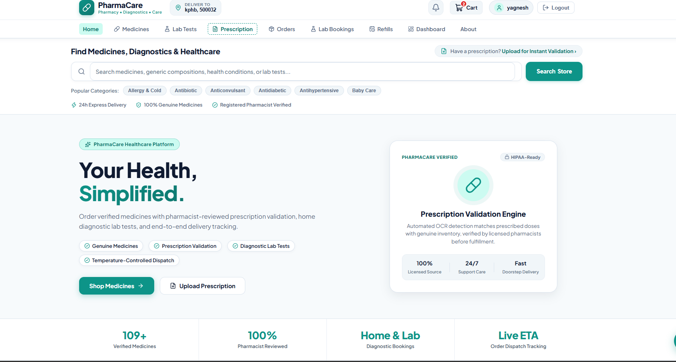
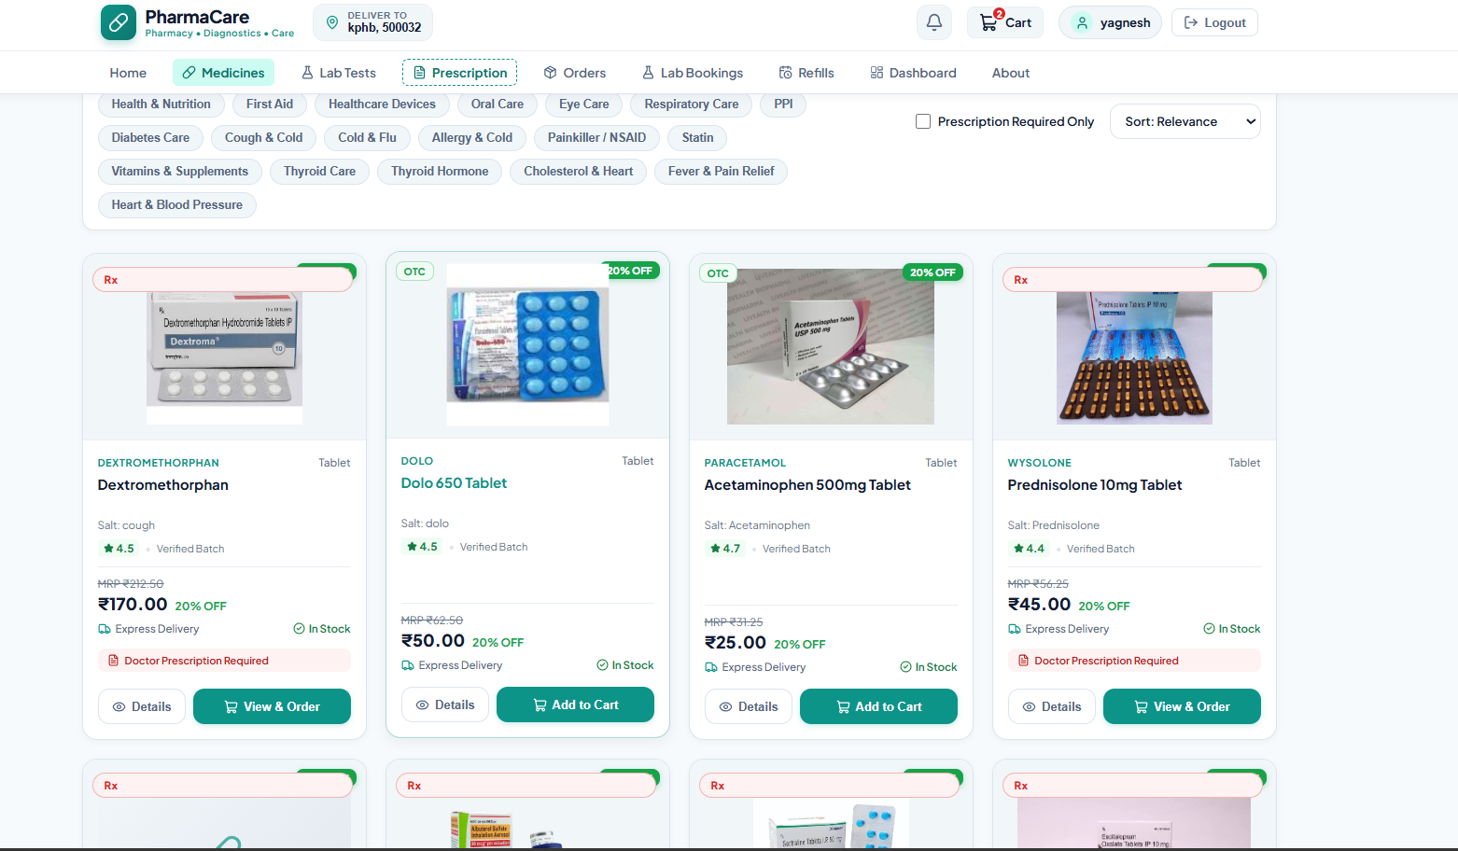
Sample code snippets
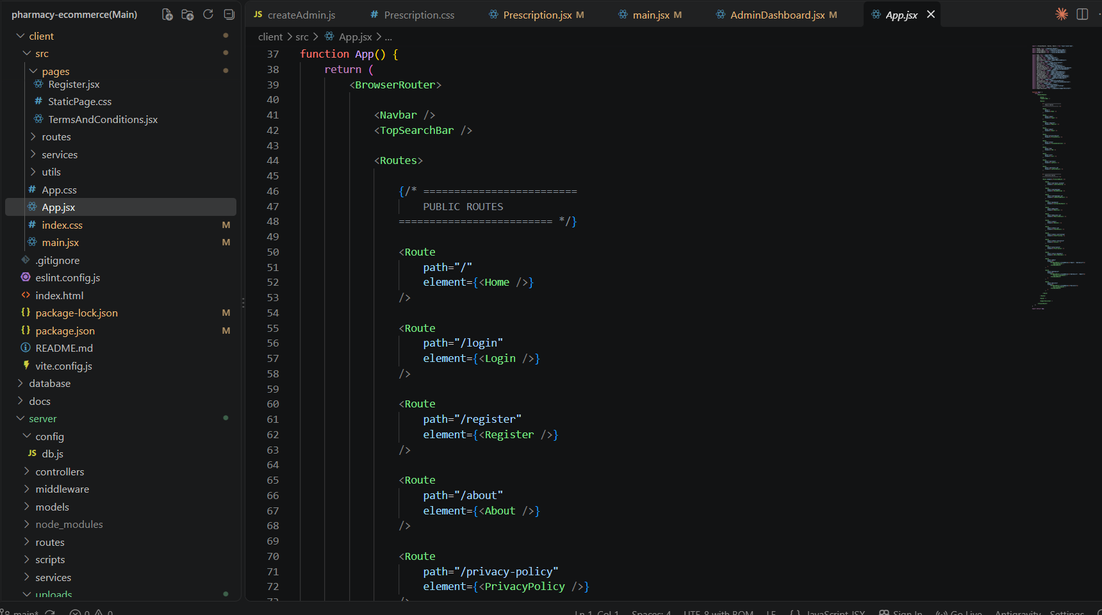
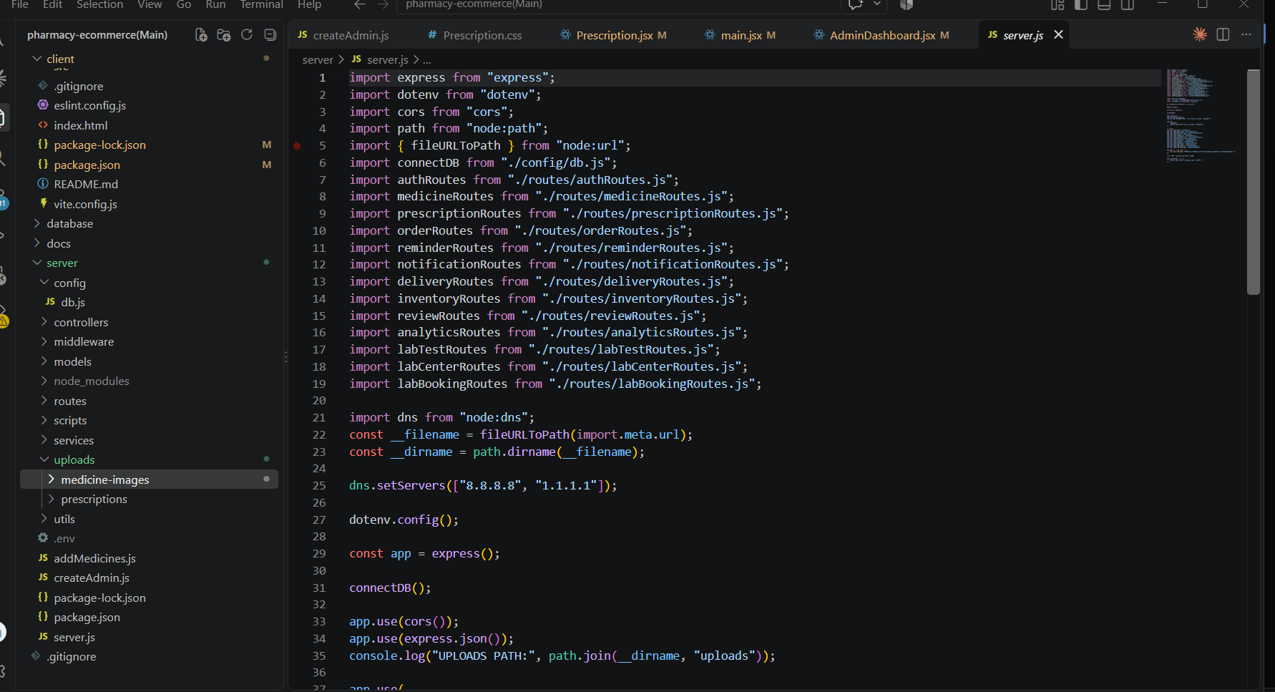
Installation/setup instructions
The PharmaCare – Pharmacy E-Commerce with Prescription Validation platform is developed using a modern full-stack architecture consisting of React.js with Vite for the frontend, Node.js and Express.js for the backend, and MongoDB with Mongoose for database management. The setup requires the installation of the necessary development tools and dependencies.
First, download or copy the complete PharmaCare project folder to the local computer. If the project is provided as a ZIP file, extract it using any standard extraction tool. Open the extracted project folder in Visual Studio Code and make sure the client, server, and other required project directories are present.
Next, install Node.js and MongoDB or configure a MongoDB Atlas database. Open the terminal inside the project directory and install the required frontend and backend dependencies using npm install. Configure the MongoDB connection and other required environment variables in the backend .env file.
After configuration, start the backend server using the appropriate npm command and run the React/Vite frontend separately. The application can then be accessed through a modern web browser such as Google Chrome, Microsoft Edge, or Mozilla Firefox. Postman can be used to test and verify the backend REST APIs.
The complete setup provides a local development environment for testing medicine management, prescription upload and validation, authentication, orders, lab bookings, dashboards, and other PharmaCare features.

Geo tag photos:


